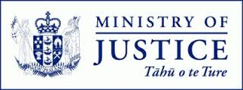
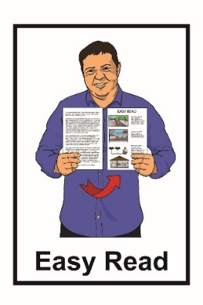

A new adoption system for
Aotearoa New Zealand

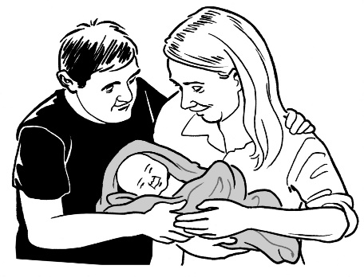

Part 1:
Have your say about adoption laws

July 2022
What you will find in here

Page number:
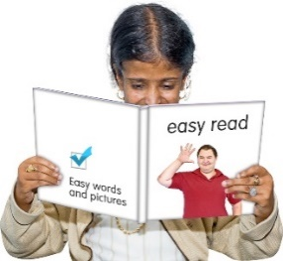

What is this document about?..................3

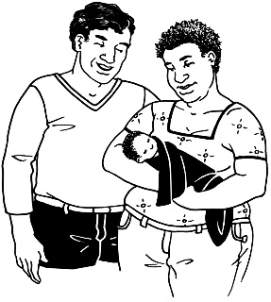

Purpose and principles of the adoption
law changes 10

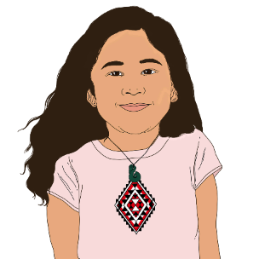
Who can be adopted? 15

Who can adopt? 16
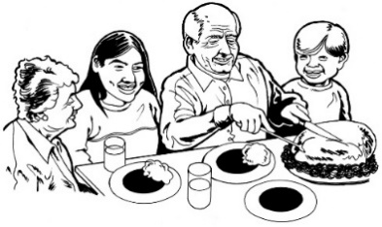

What happens if a child is placed for adoption? 20
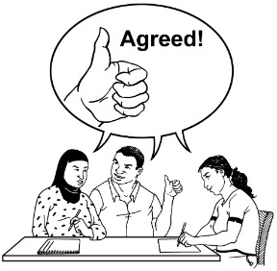

Who can have a say about the adoption? 23
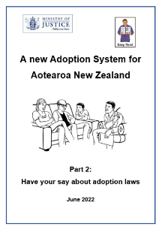
Page number:

Part 2 of the Easy Read translation 34

Tell us what you think 35

Where to find more information 38

What is this document about?

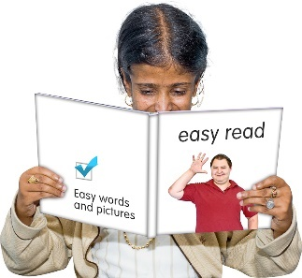
This document is about changes to adoption laws in Aotearoa New Zealand.

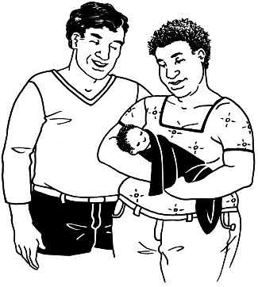
Adoption is when:
- a child is raised by a person / people who are not their birth parents

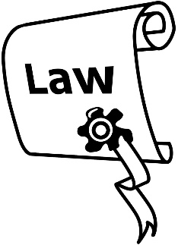
and
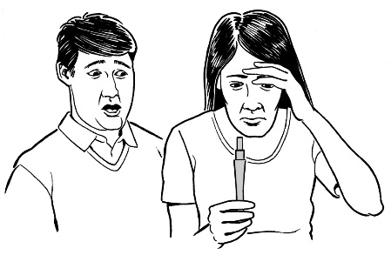
- the person / people raising the child become the legal parents of the child.

Birth parents are the people who:
- conceived / made the child
- gave birth to the child
- were the first legal parents of the child.
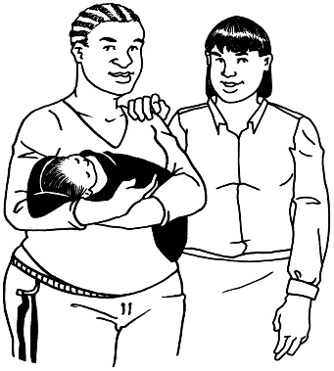
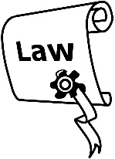
Legal parents are the people who New Zealand law says are the parents of the child.

The Ministry of Justice is looking at making new adoption laws for Aotearoa New Zealand.
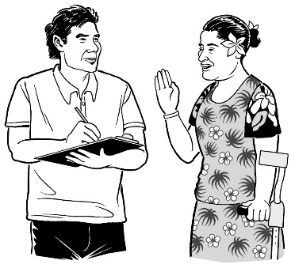

They want to know what people think about these changes.

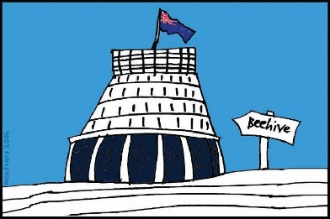
The Government will use what people say to decide the best ways to change adoption laws.

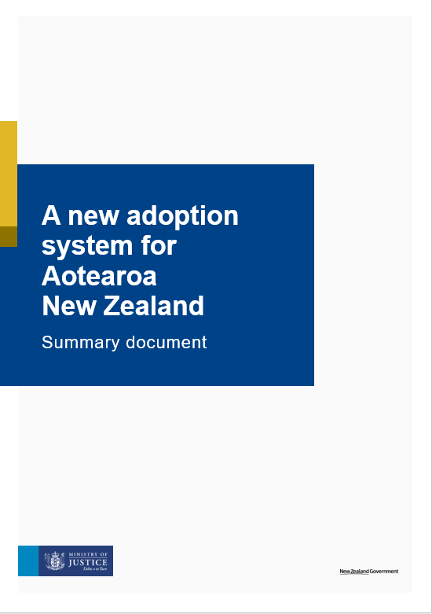
There are many reasons to look at changing the adoption laws.

The Ministry of Justice has written a document called:

A new adoption system for Aotearoa New Zealand: Summary document.

You can find this report on the Ministry of Justice website:

https://justice.govt.nz/adoption-law-reform/

In this Easy Read document we means the Ministry of Justice.

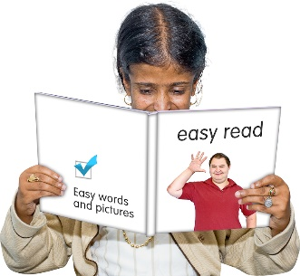
This is an Easy Read translation of the summary document.

This Easy Read translation looks at some of the main things in the summary document.
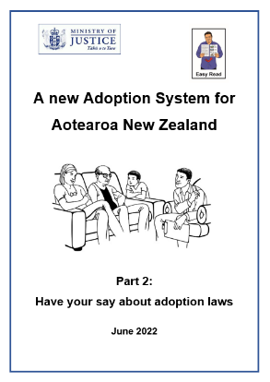
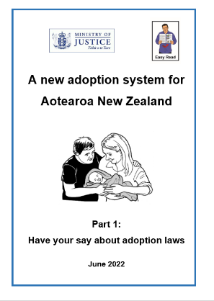

The Easy Read translation is in 2 parts.

This document is Part 1.

You can find Part 2 on the Ministry of Justice website:

https://justice.govt.nz/adoption-law-reform/
The Easy Read translation is a long document.

If you want to you can:
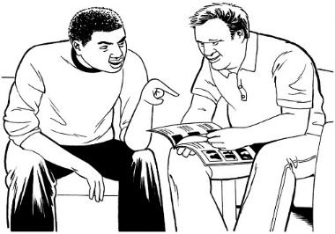
- ask someone you know to read it with you
- read a little bit at a time.

Things this document is not about

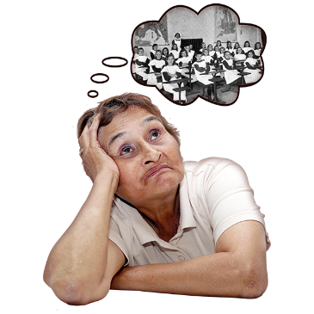
This document is not about how adoption has been done in the past.

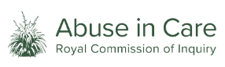
This is being looked into by the Royal Commission of Inquiry into Abuse in State Care and the Care of Faith-Based Institutions

You can find more information about the Royal Commission at this website:
www.abuseincare.org.nz

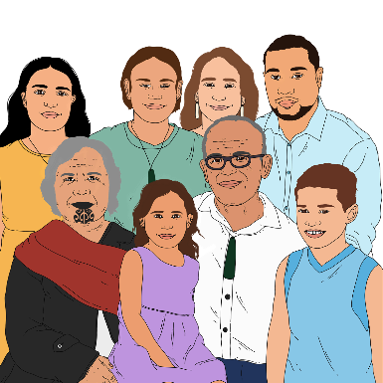
This document is not about whāngai.

Whāngai is a Māori way of children being cared for by people who are not their birth parents.
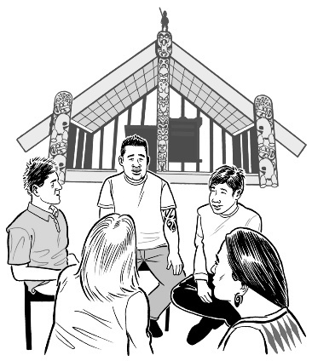
The Government will be talking to Māori about if there should be any changes to whāngai.

If you are interested in talking about that please email us at:

adoptionlaw@justice.govt.nz.

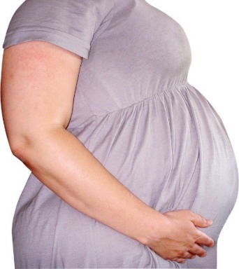
Surrogacy is also not included in this document.

Surrogacy is when someone agrees to get pregnant so someone else can have the child.

Purpose and principles of the
adoption law changes

Purpose

We think the law should say what the purpose of adoption is.

Purpose means the reasons why it happens.

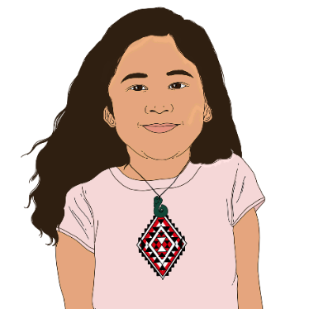
We are thinking about the purpose saying that adoption:
- is for the child
- is the best thing for the child
- will create a good family relationship.
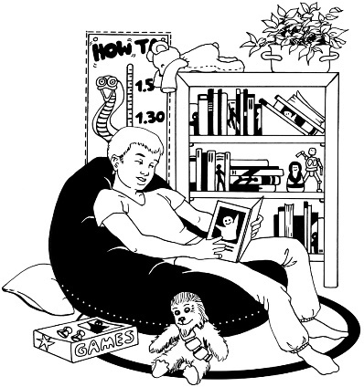
We are also thinking about the purpose saying that adoption is for children whose birth parents cannot or will not care for them.

We want to know what you think about these ideas for the purpose of adoption.

Principles

We also think the laws should include a set of principles.

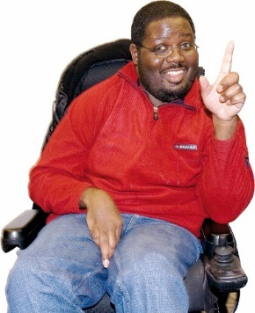
Principles are the important ideas that affect what happens.

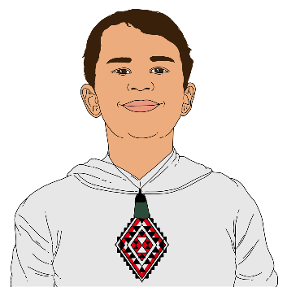
We think the principles should be things like:
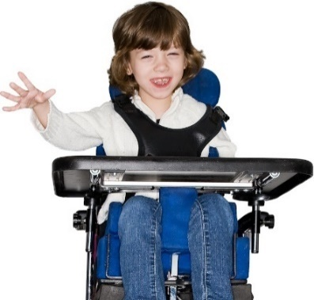
- what is best for the child is the most important thing
- the child should be asked what they think and be part of things
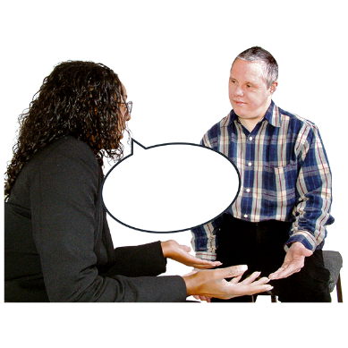
- what the child thinks should be used when making a decision
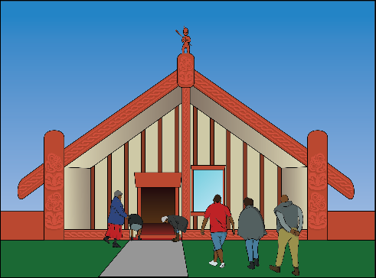
- making sure everyone knows what is happening
- knowing how people are connected in Māori culture
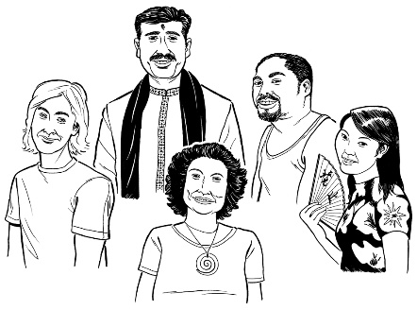
- keeping the child’s culture and identity
- protecting the child’s whakapapa.

Culture is a way of:

- thinking that a group shares
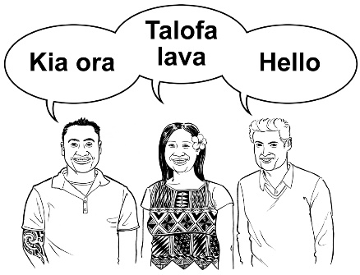
- doing things as a group.

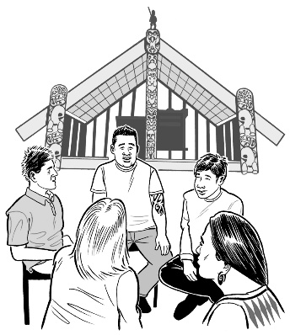
Some examples of different cultures are:

- Māori culture

- Pacifica culture
- deaf / Deaf culture.

Identity is about who you are.
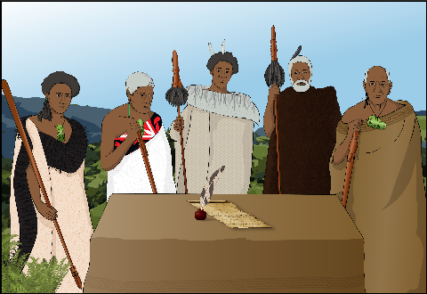

Whakapapa is about who your family is going back a very long time.

Another principle is that family / whānau should be able to be part of the adoption.

We want to know:
- what you think of these principles
- if you think there are any principles missing
- if you think there should be a principle about te Tiriti o Waitangi / the Treaty of Waitangi.

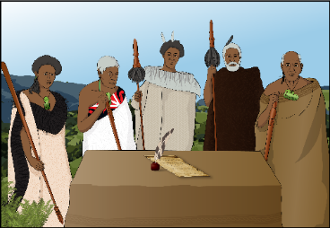
Te Tiriti o Waitangi / the Treaty of Waitangi is an important agreement between Māori and the British Crown.

Who can be adopted?

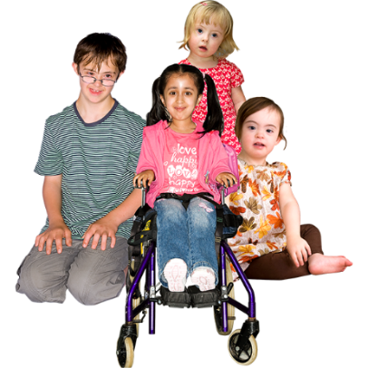
We think adoption is for children.

We do not think adults should be able to be adopted.

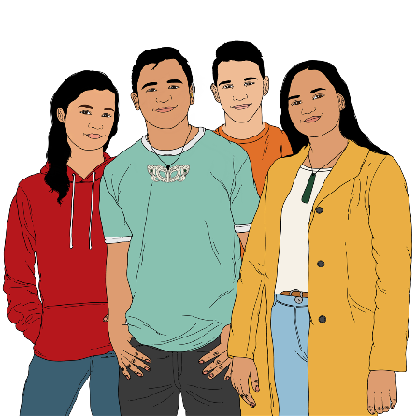
We want to know if you think the oldest people can be when they are adopted should be:
- 16 years old
or

- 18 years old.

Who can adopt?

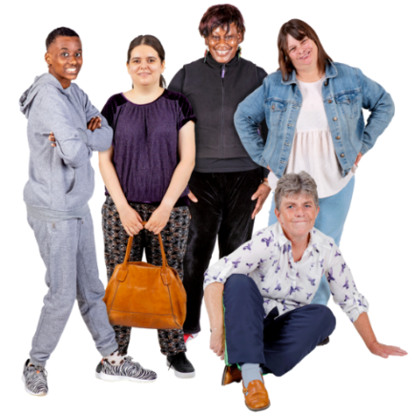
Rules about who can adopt

We think people must be at least 18 years old to adopt a child.

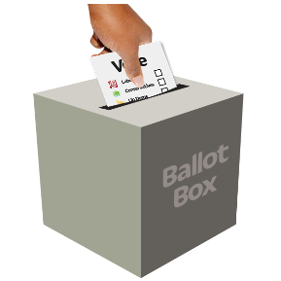
This fits with other laws about how old people should be to do other grown up things like:
- vote
- drink alcohol.

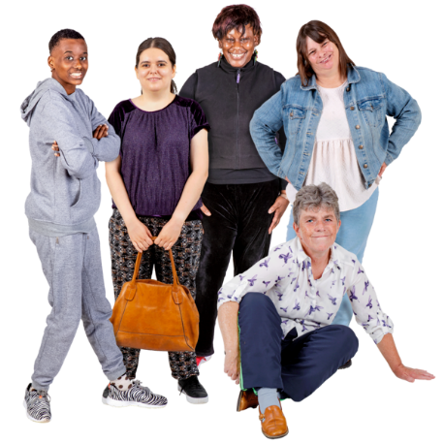
We do not think people should be stopped from a child because of their:
- sex
- relationship status.
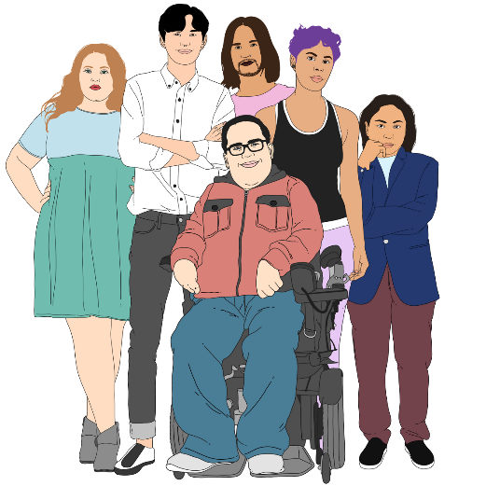
Sex is if you are:
- male
- female
- intersex.

Relationship status is things like if you:
- are single
- are married or in a civil union
- have a partner.

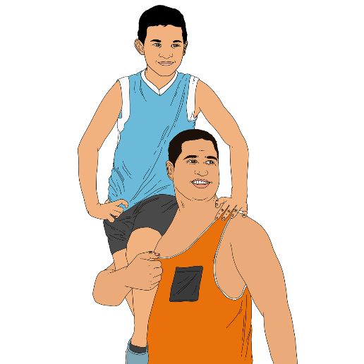
We also think step parents should be allowed to adopt their step children if it is right for the child.

A step parent is a person married to the legal parent of the child.

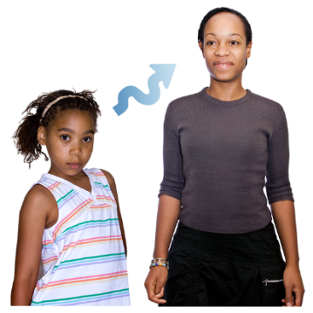
We want to know:
- if you think people should have to be 18 years or older to adopt
- any other rules you think there should be about who can adopt children.

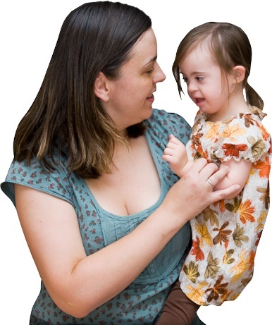
Different cultures

Some children are adopted by parents from a different culture.

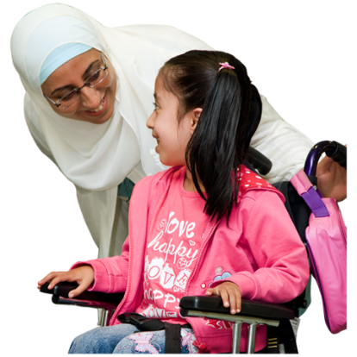
We are thinking about if it is better for the child to be adopted by people from their own culture.

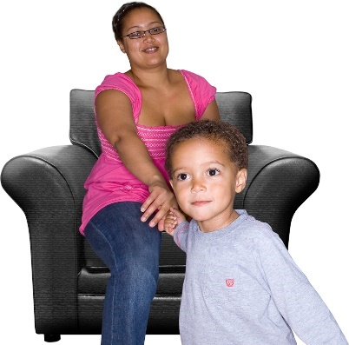
This is because it can be hard for children to stay connected to their culture if their parents are not part of that culture.

We want to know if you think the law should make it so children are more likely to be adopted by people from their own culture.

What happens if a child is
placed for adoption?

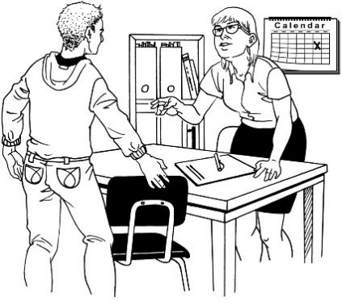
Social workers for children

We think that every child being adopted should have a social worker.

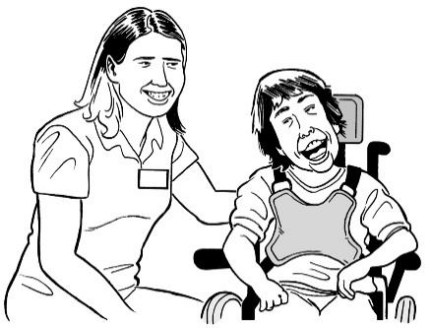
Social workers support people with things like adoption by:

- making sure the child has information about the adoption
- supporting the child to say what they think about the adoption.

We want to hear if you think children should have a social worker.

Placement before adoption

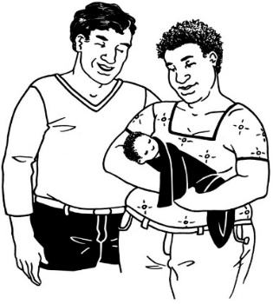
We think children should be able to live with the people who want to adopt them if:
- the social worker thinks it is a good idea
- the birth parents give informed consent.

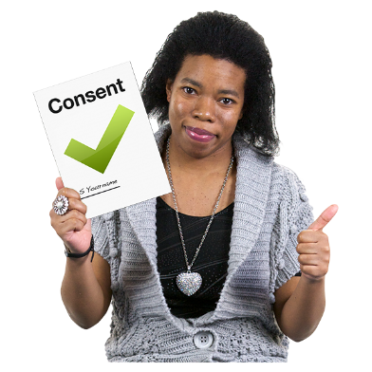
Informed consent is when you:
- say yes to something
- understand what you are saying yes to.

We want to hear what you think about the placement of children before adoption.
Other ways of caring for children

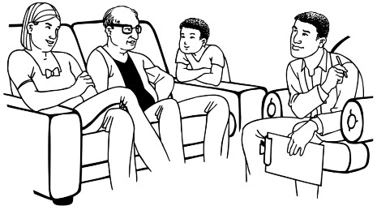
We think the social worker should have to tell the birth parents about other ways the child could be cared for.

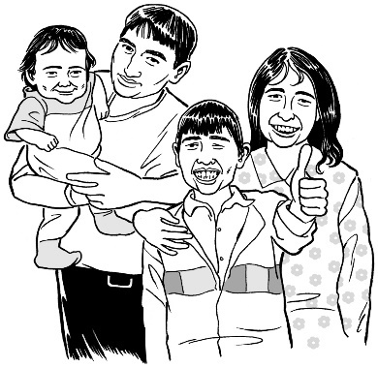
Adoption is permanent which means it:
- lasts forever
- cannot be changed unless there are special reasons to do so.
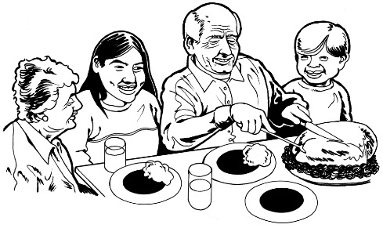

Other ways of making sure a child is cared for may not be permanent.

We want to know if you think the social worker should have to tell the birth parents about other ways the child can be cared for.
Who can have a say about the adoption?

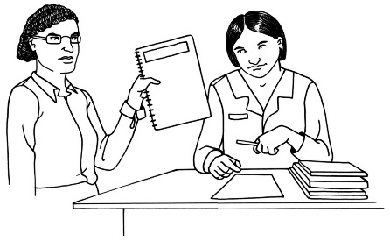
We think:

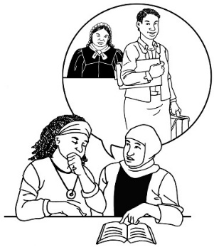
- the social worker for the child should say what the child thinks in the information they give to the court

- the child should be able to have a lawyer
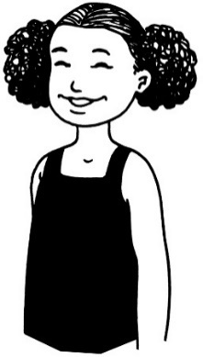
- the child should be allowed to go to court when decisions about their adoption are being made
- the child should be allowed to tell the court what they think.
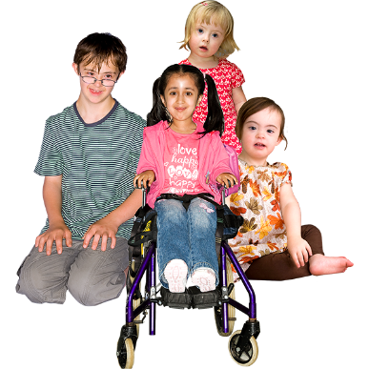

We do not think children should have to agree to being adopted.

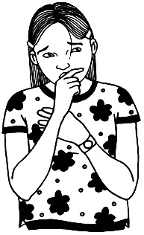
Having to decide if they should be adopted puts a lot of pressure on the child.

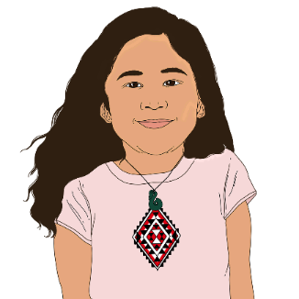
We want to hear what you think about these ways children can be part of the adoption.

Parents agreeing to adoption
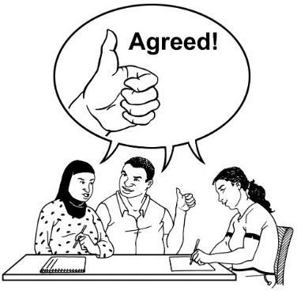

We think that in most cases both birth parents should have to agree to the child being adopted.

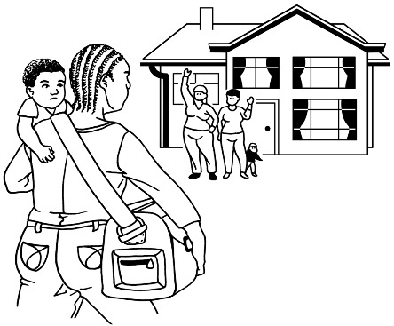
A child may be adopted without a birth parent agreeing if that birth parent:
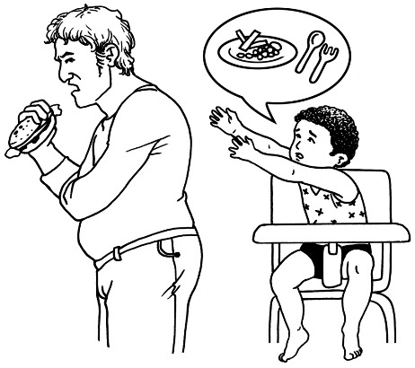
- does things that makes the child or other parent unsafe
- has not done what they should to take care of the child.

We think birth parents should have to wait 30 days after the child is born to agree to adoption.

30 days is as long as a month.
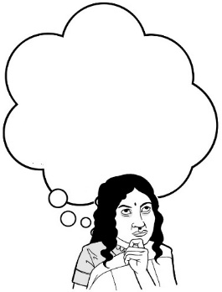
30 days gives them enough time to think about what is best.

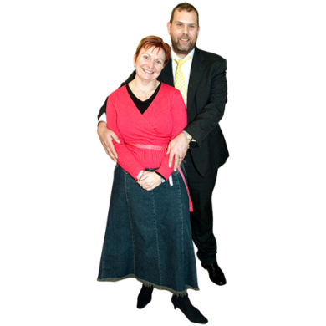
Birth parents should also be able to:
- change their minds until the adoption is confirmed
- say what they think in court.

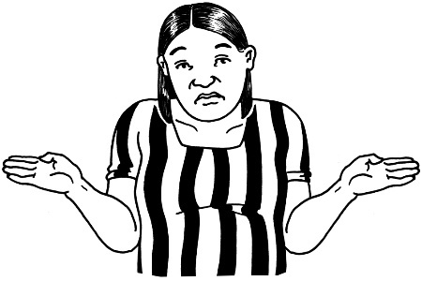
The law now says that adoption can happen without the birth parents agreeing if they do not have capacity.

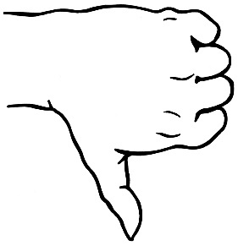
Capacity is if the court thinks a person can make legal decisions.

We do not think this should be part of the new law.

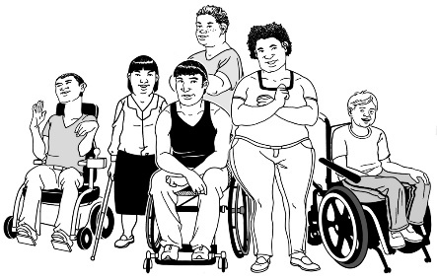
This part of the law:
- is not fair to disabled people
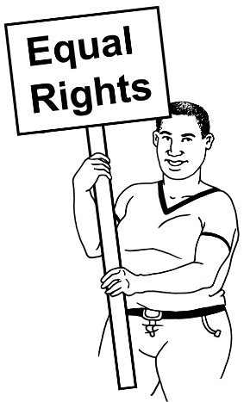
- does not fit with human rights laws.

Human rights are rights everyone should get.

We want to hear what you think about:
- if both birth parents should have to agree to the adoption
- how soon they can agree after the child is born
- when they should not have to agree.

Wider family / whānau of the child

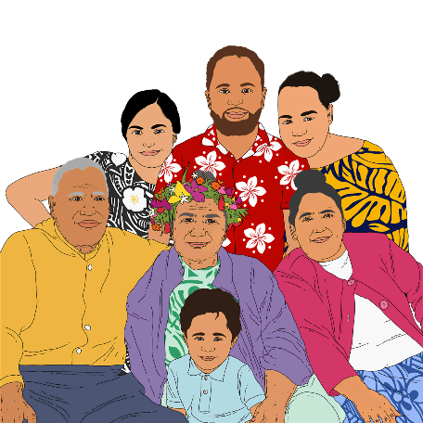
Wider family means family members of the child other than the birth parents like:
- grandparents
- aunts or uncles.

We think what wider family / whānau think should be part of the report the social worker gives to court.

This means the court can look at ways wider family / whānau may be able to care for the child.

In some cases the wider family / whānau should not be part of things.

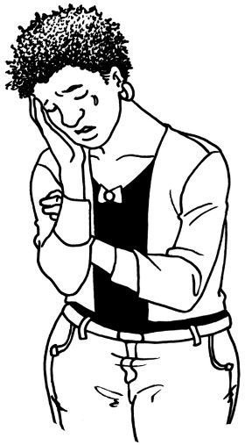
This might be because it would be very upsetting to the:
- child
- birth parents.

It needs to be decided who chooses if the wider family / whānau get involved for example:
- a government department
- the court
- the court working together with a government department.

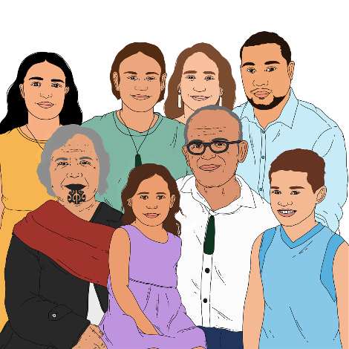
We want to hear what you think about:
- having the wider family / whānau be part of the adoption
- who decides if it would be too upsetting to have them involved.

Hapū and iwi

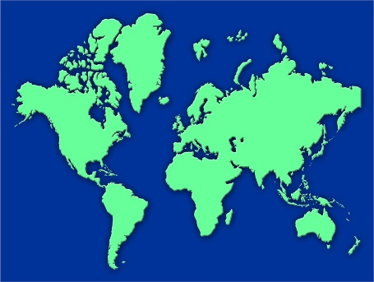
In some countries Indigenous groups have to be talked to when an Indigenous child is being adopted.

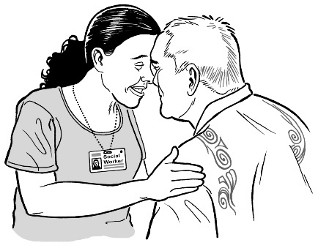
Indigenous people are the people who were in a place first.

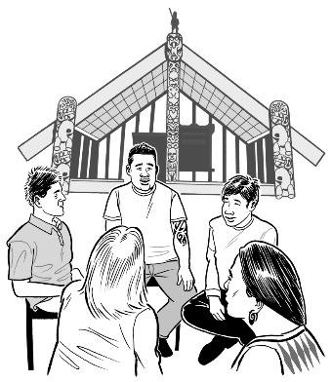
In Aotearoa New Zealand Māori are the Indigenous people.

Talking to the iwi / hapū of a tamaiti / Māori child being adopted would:
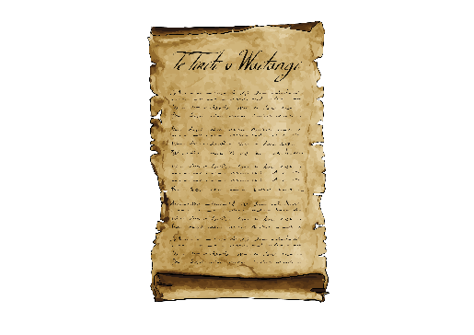
- fit with te Tiriti o Waitangi / the Treaty of Waitingi
- respect the right of Māori to make their own decisions.

We want to know if you think the iwi / hapū of a tamariki Māori / Māori child should be talked to when that child is being adopted.

Part 2 of the Easy Read translation

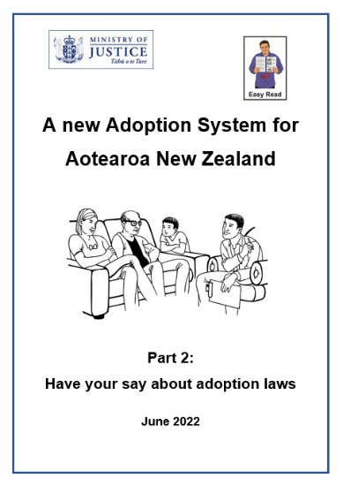
Part 2 of this translation has more:
- ideas for how the law can change
- things we want to hear what you think about.

You can find Part 2 on the Ministry of Justice website:

https://justice.govt.nz/adoption-law-reform/

Tell us what you think

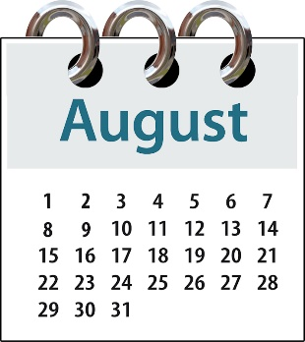
You will need to tell us what you think by:

- Sunday 7 August 2022

- 5.00 pm.

You can fill out the form on our website at:
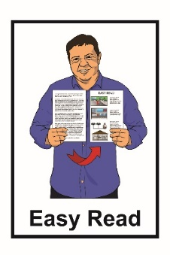
https://consultations.justice.govt.nz/

The form is not in Easy Read.

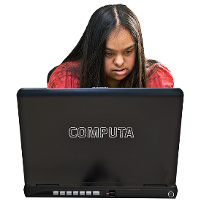
You can ask someone you know to support you with filling in the form.

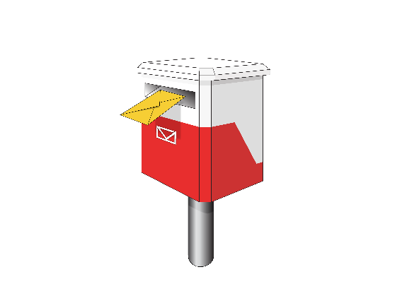
You can send us a letter at:

Adoption Law Reform

SX10088

Wellington 6011

You can email us at:

adoptionlaw@justice.govt.nz
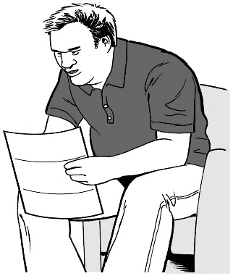
It is important to know that any information you send us could be asked for by someone else under the Official Information Act 1982.

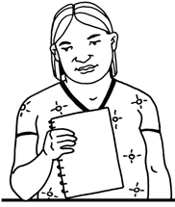
The Official Information Act 1982 is a law that lets anyone in New Zealand ask the Government for information they have.

The information asked for must be given unless there is a good reason to not give it out.

The privacy policy of the Ministry of Justice can be found at:
https://consultations.justice.govt.nz/privacy_policy/

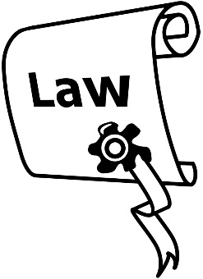
A privacy policy is a document telling you what an organisation does with any information you give them.
Where to find more information

You can find more information about this adoption law work on the Ministry of Justice website:

https://consultations.justice.govt.nz/policy/adoption-law-reform/

You can also contact us to ask for more information by:

- email:

adoptionlaw@justice.govt.nz

- phone:

04 918 8800

This information has been written by the Ministry of Justice.
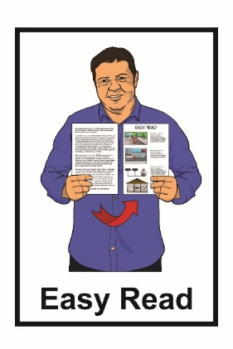
It has been translated into Easy Read by the Make It Easy service of People First New Zealand Inc. Ngā Tāngata Tuatahi.

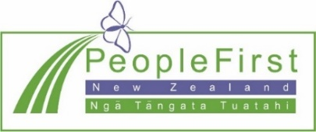
The ideas in this document are not the ideas of People First New Zealand Inc. Ngā Tāngata Tuatahi.

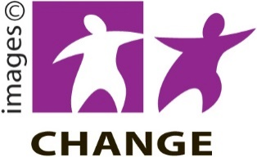
Make It Easy uses images from:

- Changepeople.org

- Photosymbols.com

- SGC Image Works

- Huriana Kopeke-Te Aho.
All images used in this Easy Read document are subject to copyright rules and cannot be used without permission.

