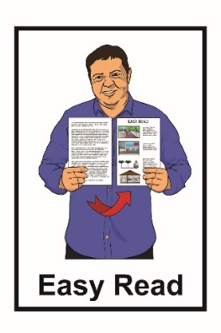
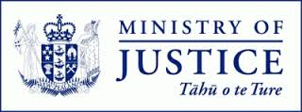

Adoption in
Aotearoa New Zealand
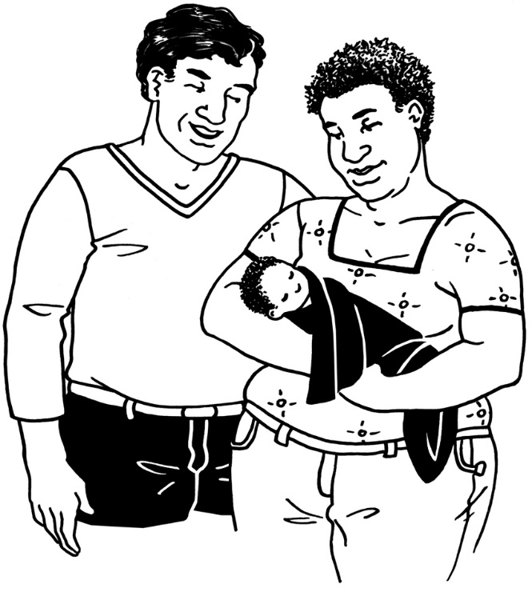

Have your say
about adoption laws

July 2021
What you will find in here

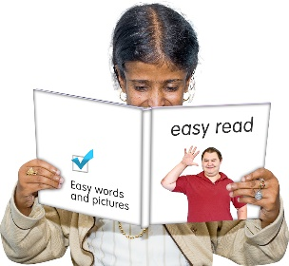
Page number:

What is this document about?..................2

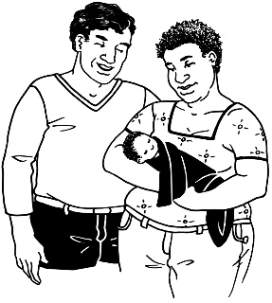
What is adoption? 5

What is adoption used for? 7

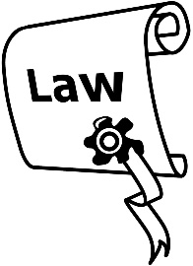
What are the adoption laws in
Aotearoa New Zealand? 12

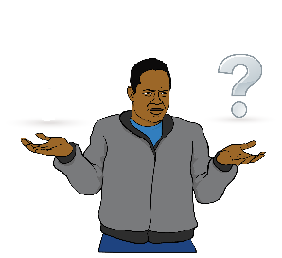
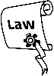
Why we need to change
adoption laws 17

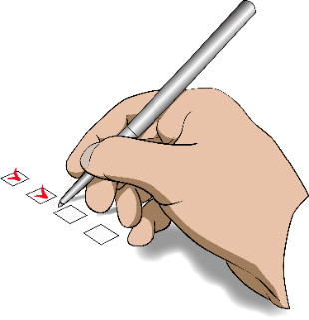
Tell us what you think …..45

Where to find more information……...….48
What is this document about?

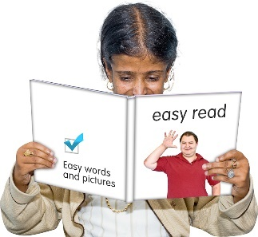
This document is about changes to adoption laws in Aotearoa New Zealand.
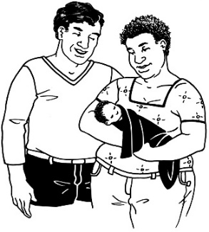

We look at what adoption means on pages 5 and 6.

The Ministry of Justice wants to hear from people about what they think of the adoption laws in Aotearoa New Zealand.
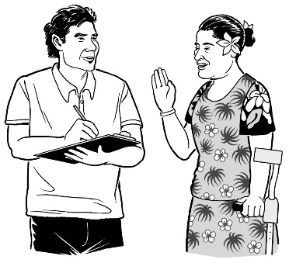
The Government will use what people say to decide the best ways to change adoption laws.

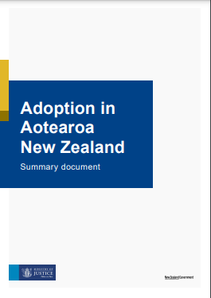
There are many reasons to look at changing the adoption laws.

The Ministry of Justice has written a document called:

Adoption in Aotearoa New Zealand: Summary document.

You can find this report on the Ministry of Justice website:

https://consultations.justice.govt.nz/policy/adoption-law-reform/

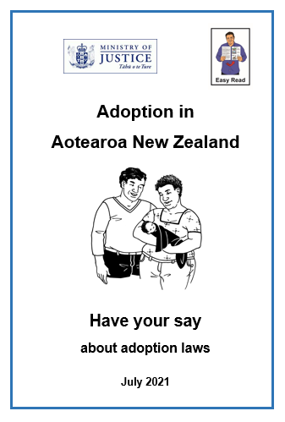
This is an Easy Read translation of the summary document.

This Easy Read translation looks at some of the main things in the summary document.

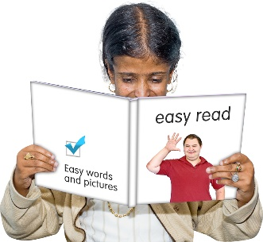
The Easy Read translation is also a long document.

If you want to you can:

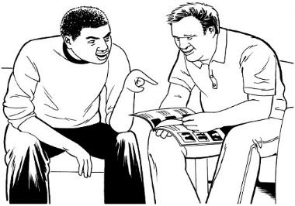
- ask someone you know to read it with you
- only read a little bit at a time.

What is adoption?

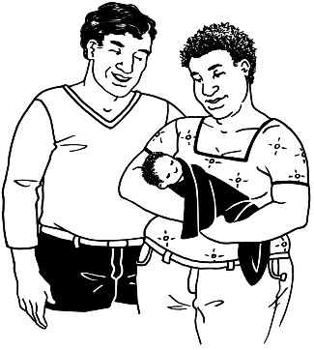
Adoption is when a child is:
- raised by someone who is not their birth parents

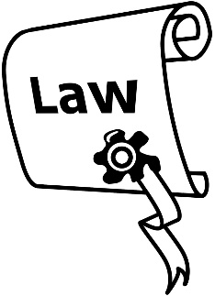
and

- the person / people raising the child become the legal parents of the child.

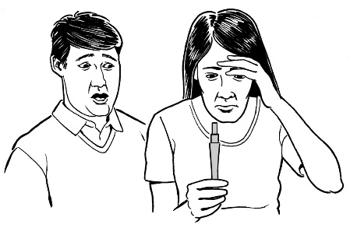
Birth parents are the people who:
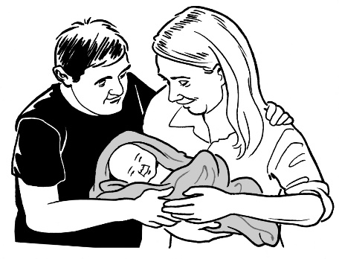
- conceived / made the child
- gave birth to the child
- were the first legal parents of the child.

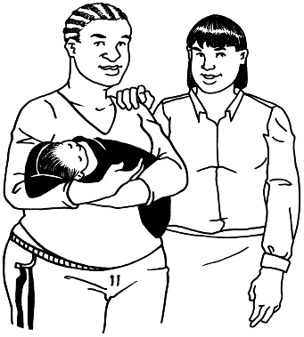
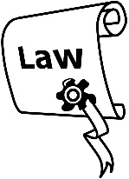
Legal parents are the people who New Zealand law says are the parents of the child.

What is adoption used for?
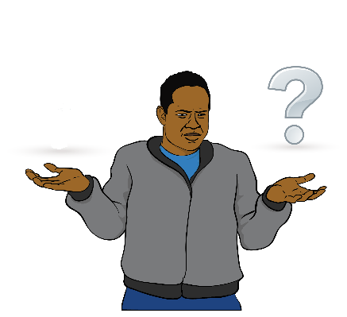
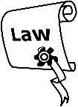
The law does not say:
- what adoption is
- when adoption should be used.
This can make it hard to know when an adoption should happen.

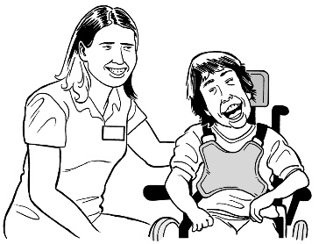
Some of the reasons adoption may happen are:
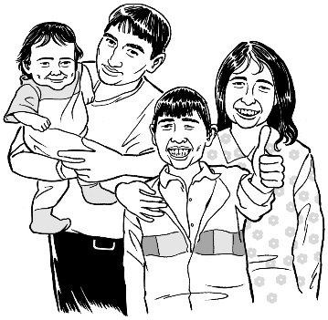
- so a child can be part of a
family / whānau who will always take care of them
- to make sure a child whose birth parents cannot care for them still has a safe home.
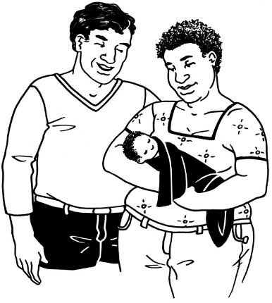
Some more of the reasons adoption may happen are:

- so people who cannot give birth can have a child
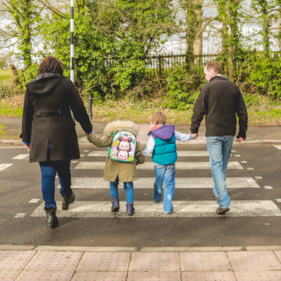
- to have a legal relationship between the child and their:
- step-parent
  - foster parent.
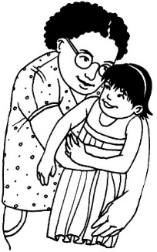
This legal relationship means that the law sees the step-parent or foster parent as a parent of the child.

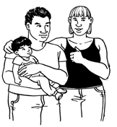
A step-parent is a person married to the legal parent of the child.

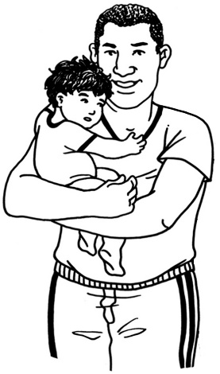
A foster parent is a person who looks after a child for a certain amount of time without becoming the legal parent of the child.

Some more of the reasons adoption may happen are:

- to bring a child from another country to Aotearoa New Zealand
- to allow families / whānau who are apart to connect with each other again
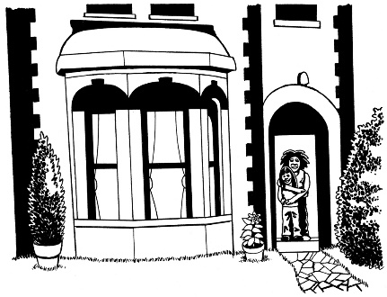
- so that so a child can inherit from their adoptive family / whānau.
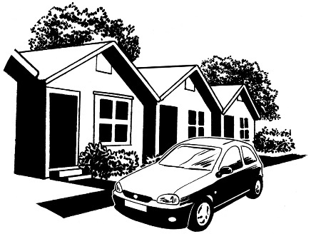
Inherit is when you get things like a house or money when a family / whānau member dies.

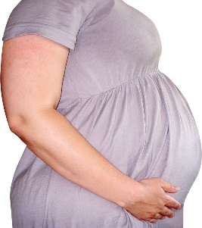
Another reason why adoption may happen is when a surrogate gives birth to a child.

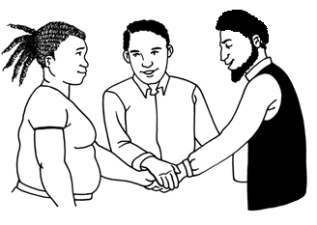
A surrogate is a woman who agrees to have a child for another person or persons.

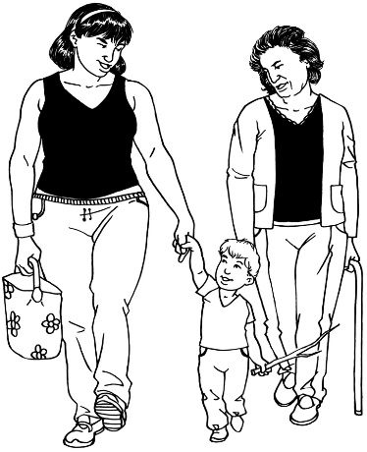
The person or persons plan the pregnancy with the surrogate.

When the child is born the person or persons then adopt the child to become the legal parents of the child.

What are the adoption laws in
Aotearoa New Zealand?

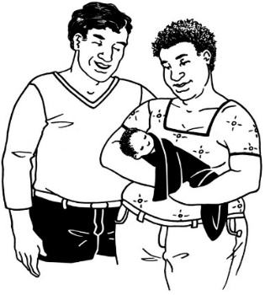
There are 3 laws about adoption in Aotearoa New Zealand.

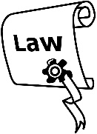
The 3 laws are:
- the Adoption Act 1955
- the Adult Adoption Information Act 1985
- the Adoption (Intercountry) Act 1997.

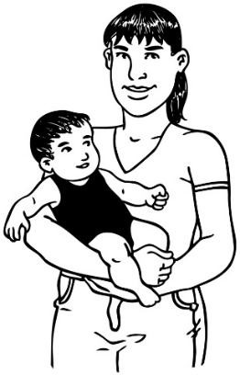
All adoptions in Aotearoa New Zealand happen under these laws.
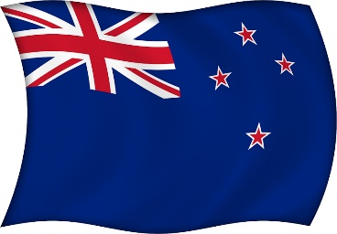
These laws allow 3 types of adoptions:

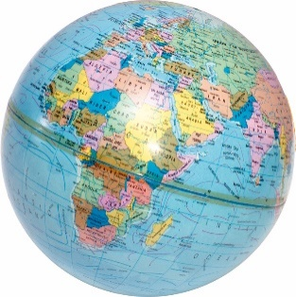
- domestic adoptions
- overseas adoptions
- intercountry adoptions.

Domestic adoptions are when:
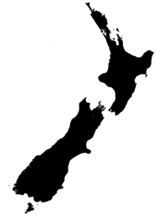
- the child being adopted lives in Aotearoa New Zealand

and
- the adoptive parents live in Aotearoa New Zealand.

Overseas adoptions are when:
- the child being adopted lives overseas

and
- the adoptive parents live overseas.

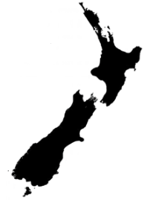

Intercountry adoptions are when the child lives in a different country to the adoptive parents.

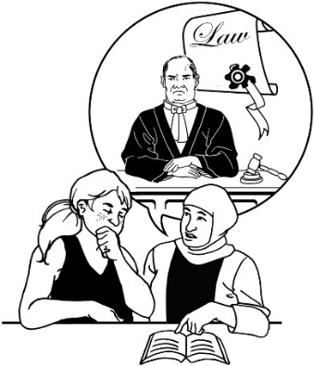
The law has not changed in a long time.

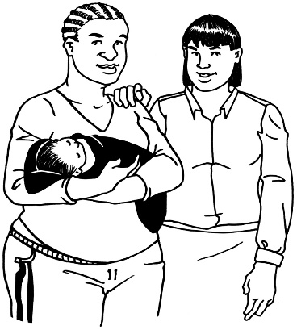
The law does not cover all the things that happen in an adoption today.

Most adoptions now are called open adoptions.

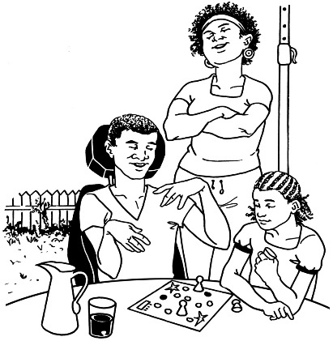
An open adoption is when the child:
- knows about their birth parents
- knows about the family / whānau of the birth parents

- might still see their birth parents.

Most adoptions in Aotearoa New Zealand in 2020 were:
- overseas adoptions
- intercountry adoptions.
The most common overseas adoptions in Aotearoa New Zealand are made from the Pacific Islands.

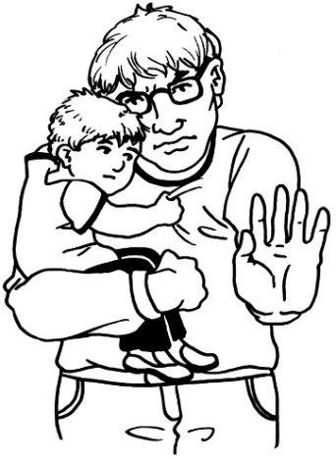
Sometimes overseas adoptions may make children unsafe.

This is because sometimes other countries may not have the same ways of protecting children as Aotearoa New Zealand.

Why we need to change adoption laws

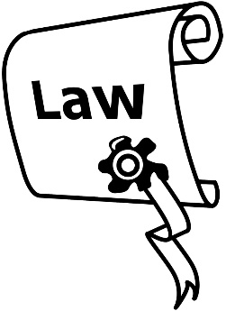
1955
The Adoption Act 1955 is the main adoption law in Aotearoa New Zealand.

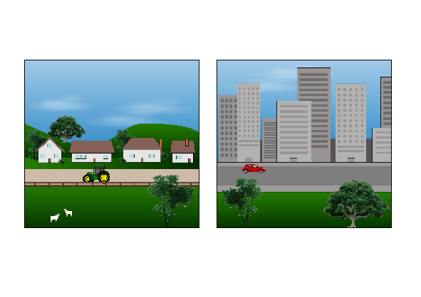
The law no longer works well as Aotearoa New Zealand has changed a lot since 1955.

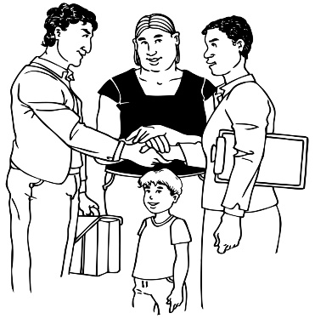
The way the law is written now means it:
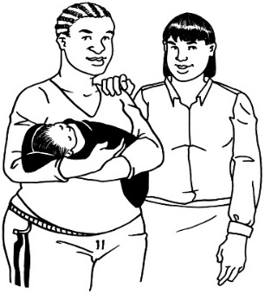
- does not fit with how people in Aotearoa New Zealand think about adoption
- does not work with the different kinds of adoptions that happen in Aotearoa New Zealand.

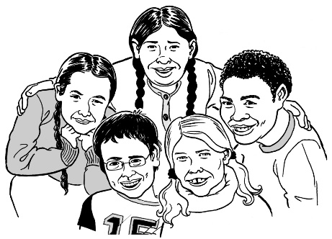
The way the law is written now also means it does not look after the rights of the children in an adoption enough.

Adoption affects everyone who is part of an adoption for their whole lives.

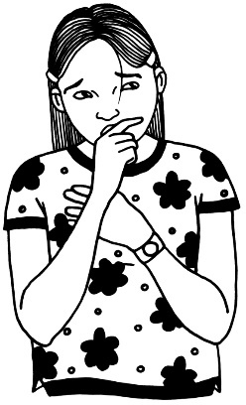
It can affect their lives in ways such as:
- not knowing who they are as a person
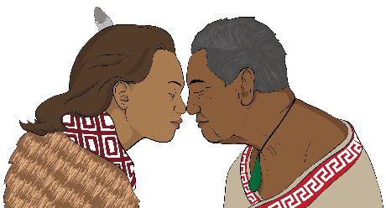
- losing the culture of their birth family / whānau.
- losing the language of their birth family / whānau.

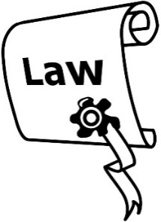
We are looking at changing our adoption laws to make them better so that we can:
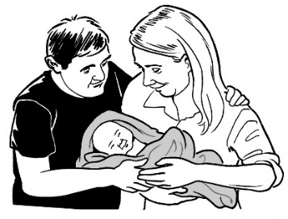
- have safe adoption laws
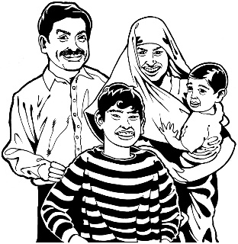
- have adoption laws that look after everyone who is part of an adoption
- put the needs of children first
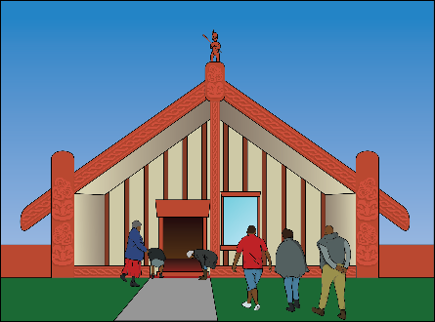
- have laws that think about the cultural needs of everyone who is part of an adoption

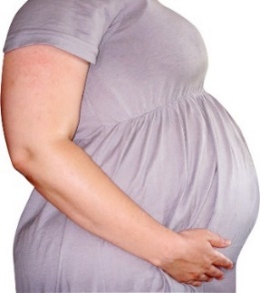
- make the adoption process easier for people who have a child born by a surrogate.

There are many reasons to look at changing the adoption laws.

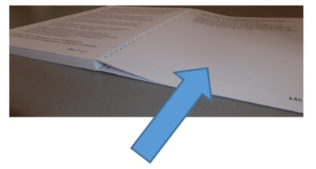
On pages 21 to 44 we look more closely at some things about adoption that you might want to have your say on.

- Tamariki Māori

Tamariki is the Māori word for children.

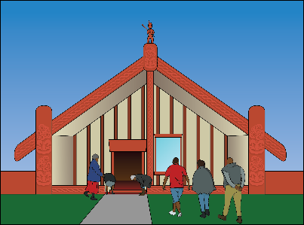
Tamariki Māori who are adopted can:
- feel like they are not a part of their culture
- find it hard to connect with their whakapapa
- find it hard to connect with their whenua.

Whakapapa is the importance of knowing about:

- where you are from
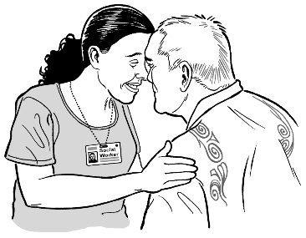
- who you are

- your whānau history / stories.

Whenua is about the connection to the land.

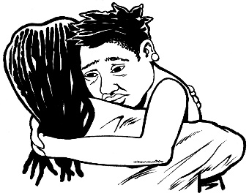
Tamariki Māori are more likely to be affected in these ways when adopted by a non-Māori whānau.

We want to know:
- what things need to happen when tamariki Māori are adopted?

- do you think whāngai arrangements need to be part of the adoption law?

Whāngai arrangements are where a child is taken care of by other people in their whānau / family.

- Timing of consent and withdrawing consent

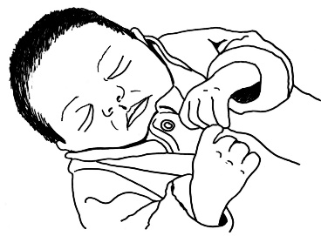
The law says a birth mother cannot give their consent to an adoption until the child is at least 10 days old.

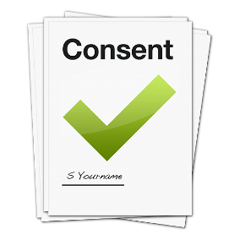
Consent is when you get to choose if you agree to something.

10 days
Some people think that 10 days is not enough time for a birth mother to make a decision about their child being adopted.

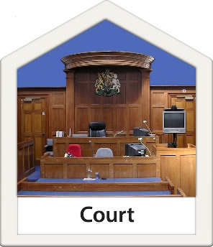
The law also says that birth parents cannot withdraw their consent while:

- the application for adoption is still being looked at by the Courts

or

- until the adoptive parents have had enough time to apply to adopt the child.

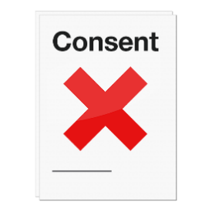
Withdrawing consent means the birth parent or parents no longer consent to the child being adopted.

We want to hear from you about:
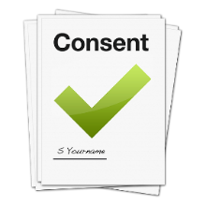
- when do you think a birth parent or parents should be able to give their consent to an adoption?
- what should happen if a birth parent or parents want to withdraw their consent?
- Disabled parents

Another reason to look at adoption laws is to look at the dispensing with consent rule.

Dispensing with consent is about times the Family Court does not need the consent of the parents when making a decision about the child.

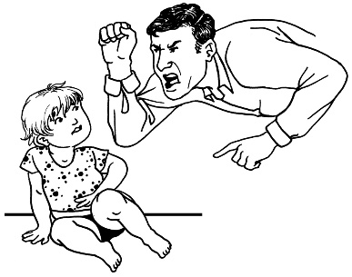
The court can dispense with consent when there are concerns about the:

- safety of the child
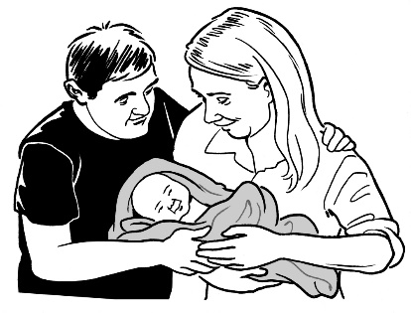
or

- disabled parent or parents being able to care for their child.
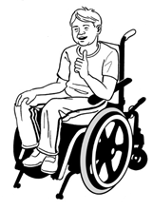
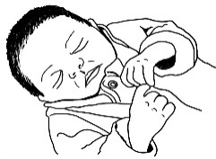
For some disabled parents this can mean the Family Court can decide that they do not have the:

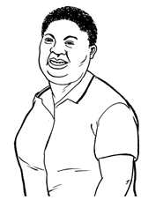
- physical ability to care for a child

or

- mental ability to care for a child.

Physical ability is about things like being able to move or carry a child.

Mental ability is about things like:
- what you understand about caring for a child
- remembering to do things when caring for a child.

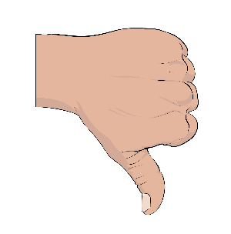
Some people say:

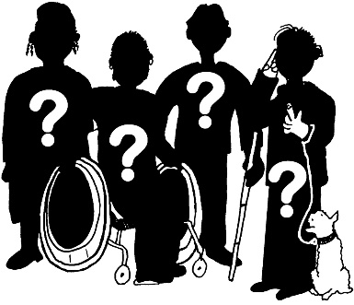
- this rule does not see that disabled parents can be good parents

- that there needs to be changes to the dispensing with consent rules.

We want to hear about what you think of the dispensing with consent rules.

- What makes good adoptive parents?

People looking to adopt need to be able to show that they are fit and proper to be parents.
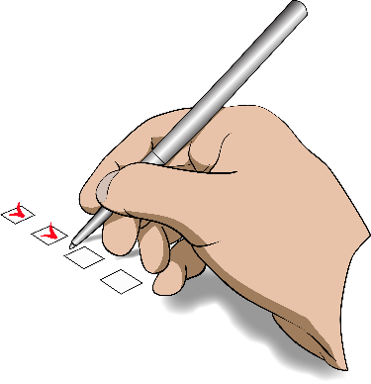

Fit and proper means that adoptive parents are able to give the child the care they need each day.

The law does not say what things make a fit and proper person.

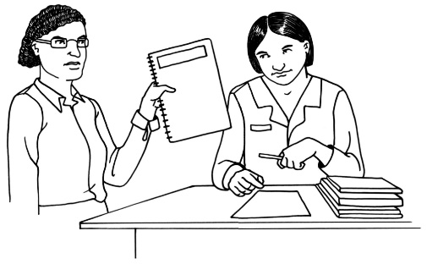
At the moment a social worker from
Oranga Tamariki writes a report to court about whether a person or people would make good adoptive parents.

The court looks at the report to make a decision about the person or people wanting to adopt a child.

We want to hear your views on:
          - if the law should say what fit and proper means more clearly

          - what things should be in the fit and proper list?

- Court time and cost

Some people think that the court takes a long time to make final decisions about adoptions.

In most cases the court must make an interim order that lasts around 6 to 12 months.

An interim order is a decision that only lasts for a short time.

An interim order gives time for:

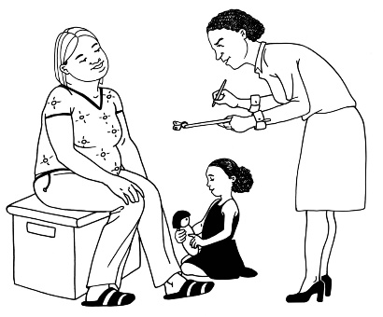
- the adoptive parents to get to know the child

- Oranga Tamariki to check that the adoption is working well for the child.
6 to 12 months after the interim order is made the adoptive parents can ask for a final adoption order.

A final adoption order means the adoptive parents become the parents of the child.

Some people say:
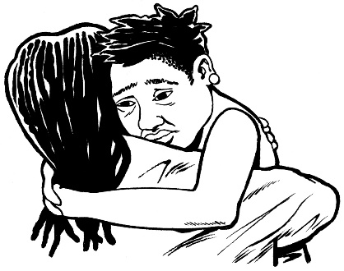
- it is a very worrying time for everyone while they are waiting for the final adoption order

- it can also cost a lot of money because a lawyer is often needed to work with the court

- not everyone has enough money for a lawyer which makes it unfair.

We want to hear about what changes you think should be made to the types of orders the court makes for adoption cases.

Staying connected with birth family / whānau
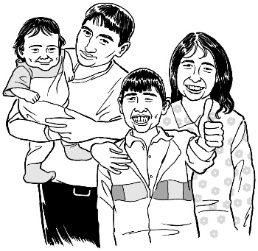

Adoption is a permanent way of caring for a child when their birth parents cannot care for them.

Permanent means the adoptive parents will always be seen as the parents of the child.

The law says that when a child is adopted:

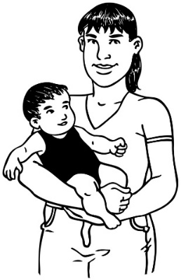
- the birth family / whānau no longer have any rights to be part of the child’s life

- the adoptive parents get the right to make all the decisions about the child.

We know that:

- this does not fit with how open adoptions work in Aotearoa New Zealand today

- it is not good for the child to not know about their:

- family / whānau

- culture.

There are other types of care such as guardianship orders where the child can stay more connected to their birth family / whānau.

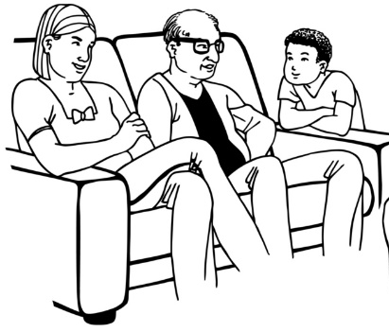
A guardianship order means someone is able to make legal decisions about the care of the child but is not the legal parent of the child.

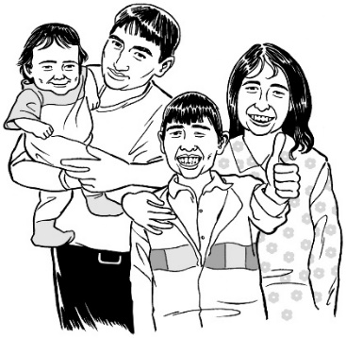
We want to hear from you about:

- how important it is to know about the birth family / whānau?
- what other types of care arrangements could there be?

Stopping an adoption order
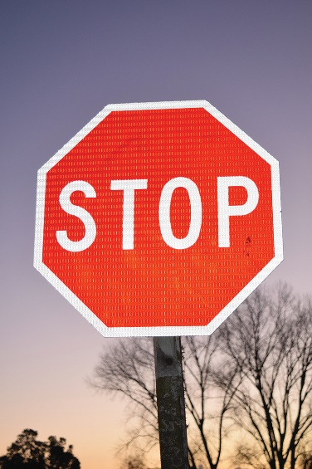

The law says that an adoption order may be stopped if:

- the consent from the birth parents was given because they were:

  - not told the truth about things
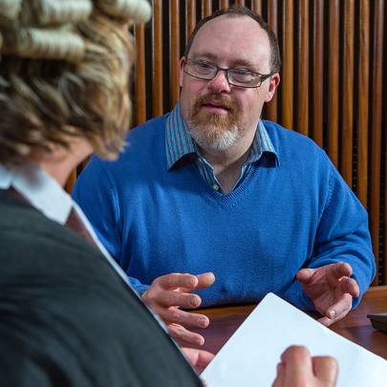
  - forced to give consent

or

- there was false evidence given in court.

False evidence is things like:
- when a person or people do not tell the truth in court

- when documents do not have the truth written down.
If an adoption order is stopped the birth parents go back to being the legal parents of the child.

Stopping an adoption can:
- be hard to do

- cost a lot of money.

We want to hear about when you think an adoption order should be able to be stopped.

Adoption support services
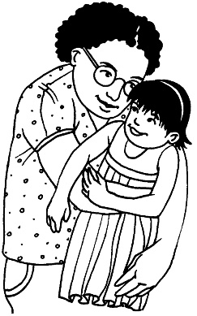

We know that adoption affects everyone who is part of an adoption.

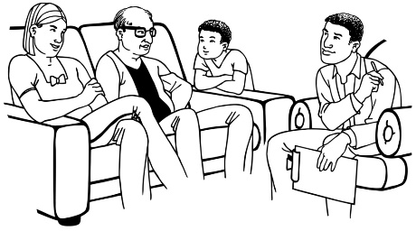
People who are part of an adoption often need:

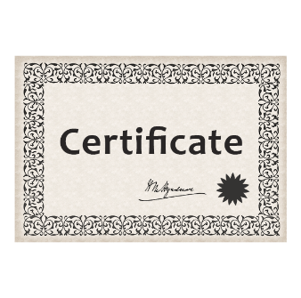
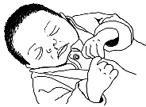
- support

- information.

People may need this support / information:

- before an adoption
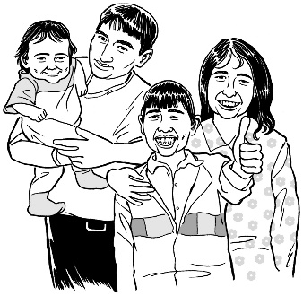
- during an adoption

- after an adoption.

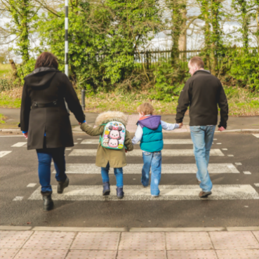
The people who need this support / information can be:

- children who are being adopted

- children who have been adopted.

- adults who were adopted when they were a child

- adoptive parents

- birth parents

- wider family / whānau.

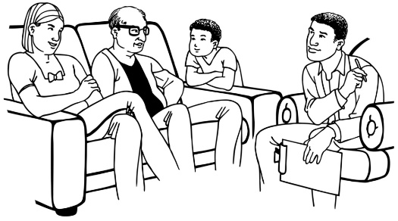
We want to hear from you about what support you think there should for everyone who is part of an adoption.

Birth certificates after an adoption

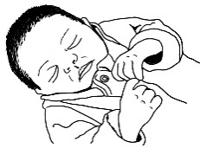
Every person born in Aotearoa New Zealand has information about their birth recorded on a birth certificate.

A birth certificate is a document that has information about the:

- date the person was born
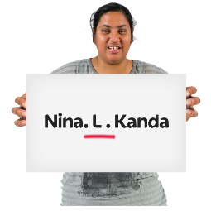
- place where they were born

- names of the birth parents.

When a person is adopted the names of the adoptive parents is put on a new birth certificate.

The new birth certificate does not have the names of the birth parents.

We want to hear about what you think should be on a birth certificate once a person has been adopted.

Adoption information

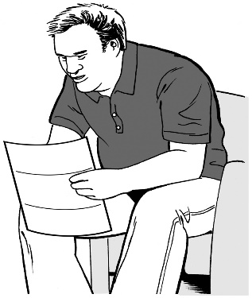
It is not always easy for a person who has been adopted to get information about their birth parents.

The person who is adopted must be at least 20 years old before:

- they can ask for a copy of the first birth certificate with the names of their birth parents on it
- the birth parents can ask for a copy of the first birth certificate.

Other family / whānau are not able to ask for this birth certificate.

We want to hear about:

- who you think should be able to get adoption information?

- how they should be able to get adoption information?

Tell us what you think

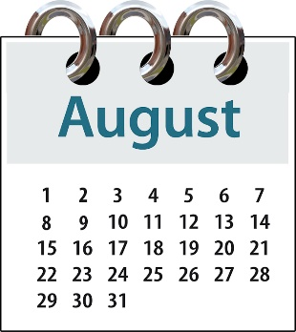
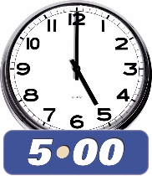
You will need to tell us what you think by:

- Tuesday 31st of August 2021

- 5.00 pm

You can fill out the form on our website at:
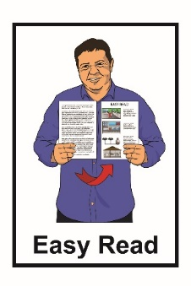
https://consultations.justice.govt.
nz/policy/adoption-law-reform/

The form is not in Easy Read.

You can ask someone you know to support you with filling in the form.

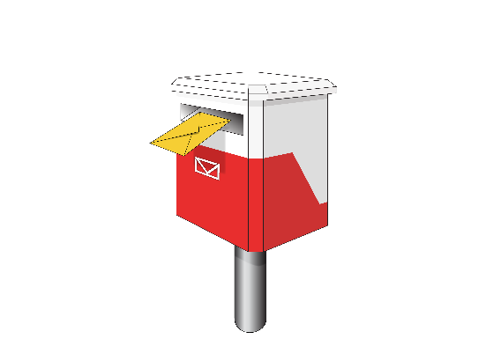
You can send us a letter at:

Adoption Law Reform

Ministry of Justice

Free Post 113

PO Box 180

Wellington 6140

You can email us at:

adoptionlaw@justice.govt.nz
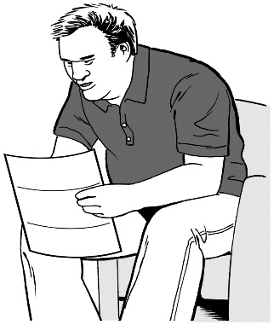
It is important to know that any information you send to us could be asked for by someone else under the Official Information Act 1982.

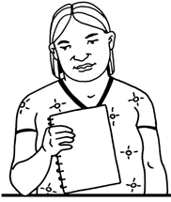
The Official Information Act 1982 is a law that lets anyone in New Zealand ask the government for information they have.

The information asked for must be given unless there is a good reason to not give it out.

The privacy policy of the Ministry of Justice can be found at:
https://consultations.justice.govt.nz/privacy_policy/

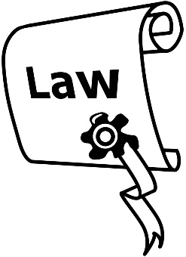
A privacy policy is a document telling you what an organisation does with any information you give them.
Where to find more information

You can find more information about this adoption law work on the Ministry of Justice website:

https://consultations.justice.govt.nz/policy/adoption-law-reform/

You can also contact us to ask for more information by:

- email:

adoptionlaw@justice.govt.nz

- phone:

04 918 8800

This information has been written by the Ministry of Justice.

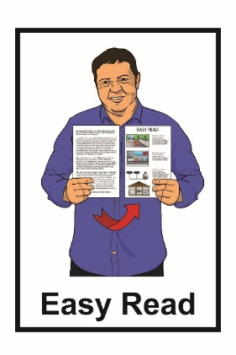
It has been translated into Easy Read by the Make It Easy service of People First New Zealand Inc. Ngā Tāngata Tuatahi.

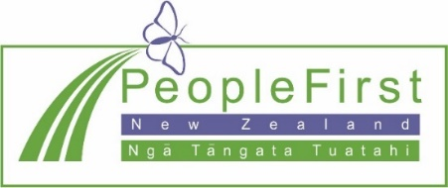
The ideas in this document are not the ideas of People First New Zealand Inc. Ngā Tāngata Tuatahi.
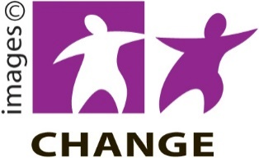

Make It Easy uses images from:

- Changepeople.org

- Photosymbols.com
- Sam Corliss.

All images used in this Easy Read document are subject to copyright rules and cannot be used without permission.

